Chapter 7, Problem 81.

Repeat Prob. 7.65 using PSpice.

Chapter 7, Problem 65.

If the input pulse in Fig. 7.130(a) is applied to the circuit in Fig. 7.130(b), determine the response i(t).

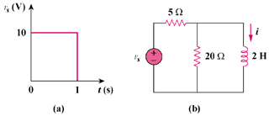

Figure 7.130
For Prob. 7.81.

